1. How Microsoft 365 Copilot works

<https://www.youtube.com/watch?v=3Nb0FEe3kKw&t=382s>

1. Extend Copilot for Microsoft 365

<https://www.youtube.com/watch?v=NJ017ioGsiA>

1. Introduction on extending Copilot for Microsoft 365

<https://www.youtube.com/watch?v=5ifBWFlO6p0&t=7s>

**Microsoft Copilot for M365**

An AI-powered productivity tool that uses large language model (LLM) and integrate your data with the Microsoft Graph and Microsoft 365 Apps.

It is made of a lot of different elements:

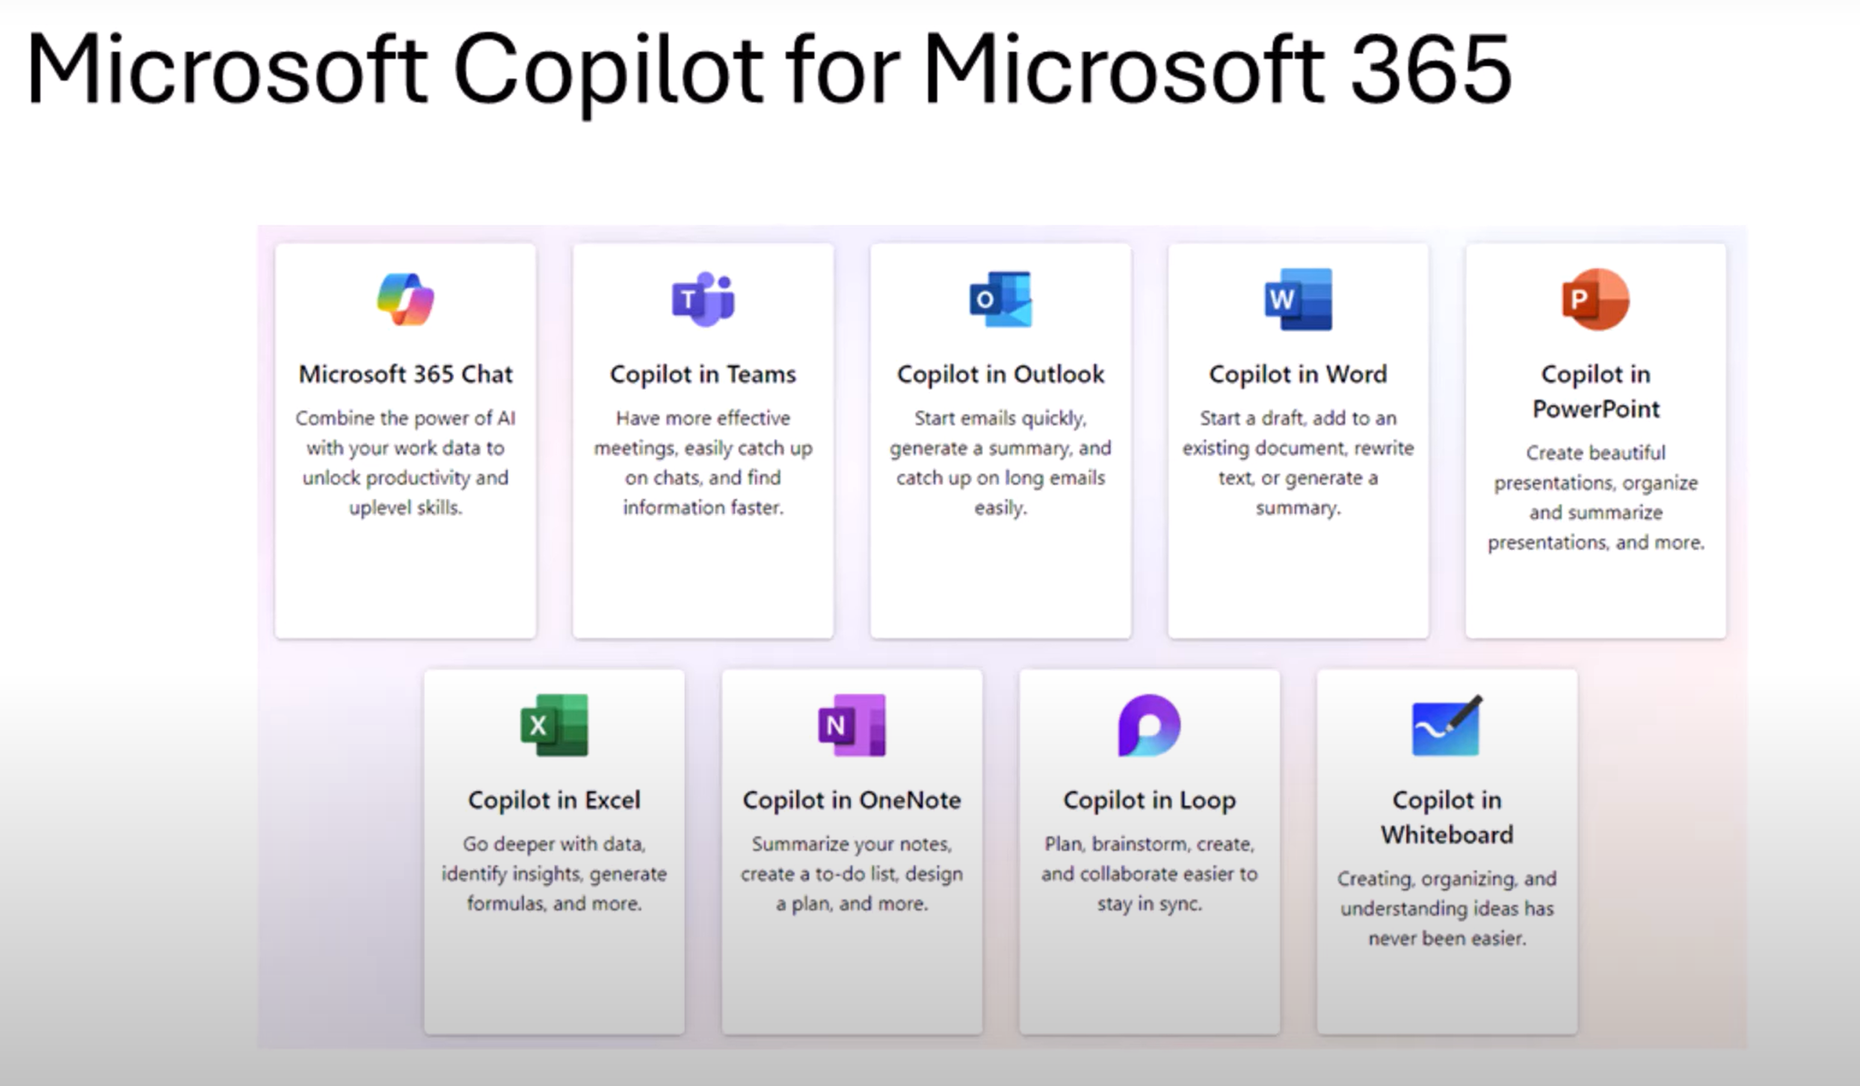

M365 chat is available in Teams as an app, in office.com and through ping.com (to question about company data)

**NB:** When talking about extensibility, we talk about Microsoft 365 Chat.

How Semantic Index for Copilot works in Microsoft 365

<https://www.youtube.com/watch?v=Ii3l13nx9n4&t=12s>

**Semantic Index (related data)**

**Correlate activity singles by bringing index items**

* Tenant level
* User level
* 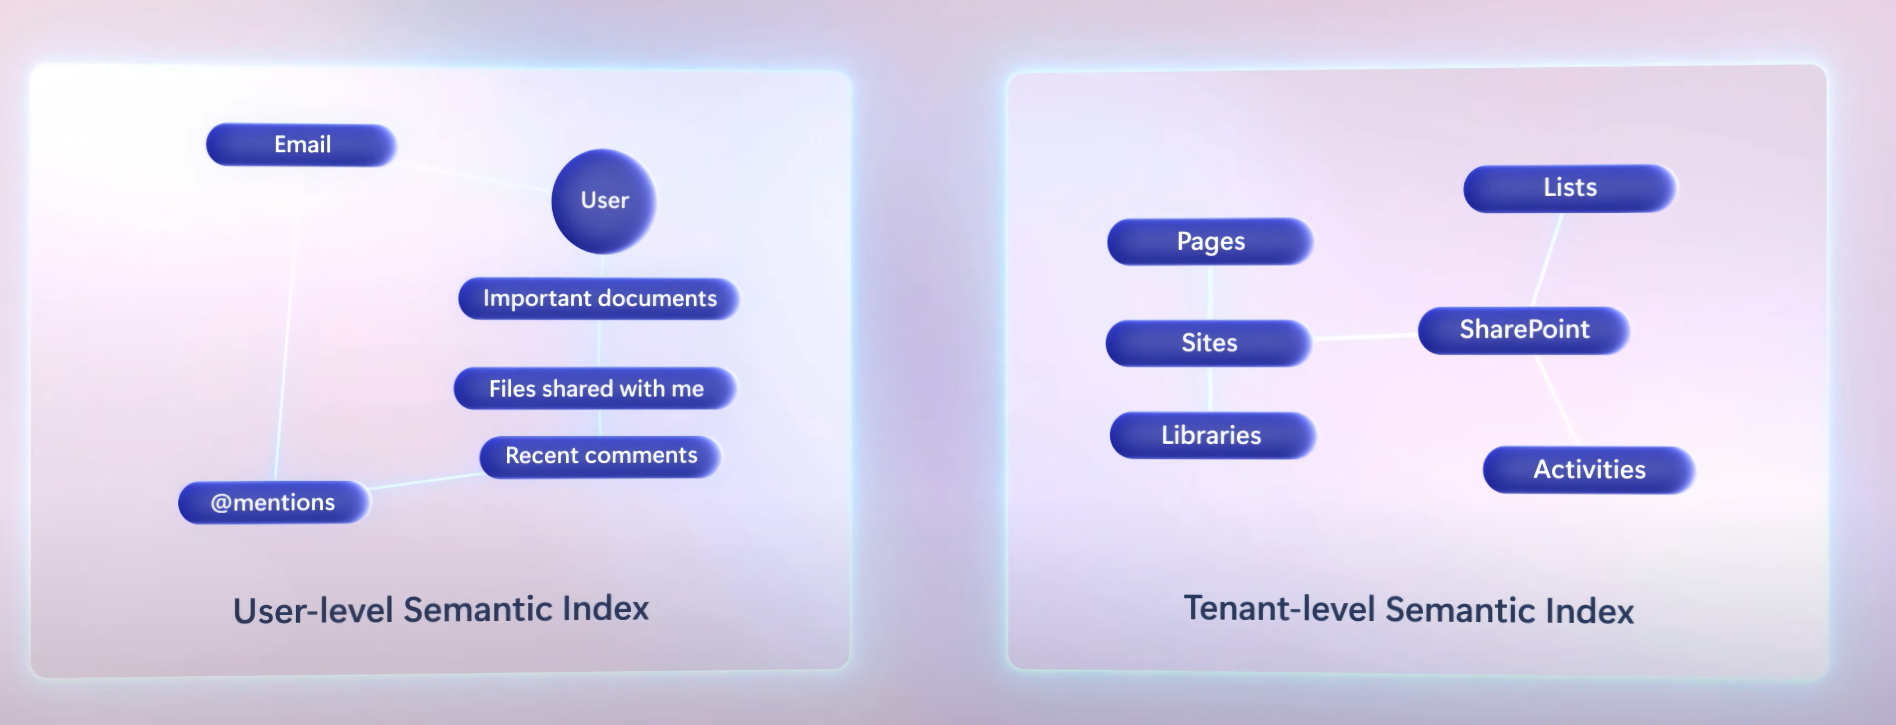

Two ways to extend copilot:

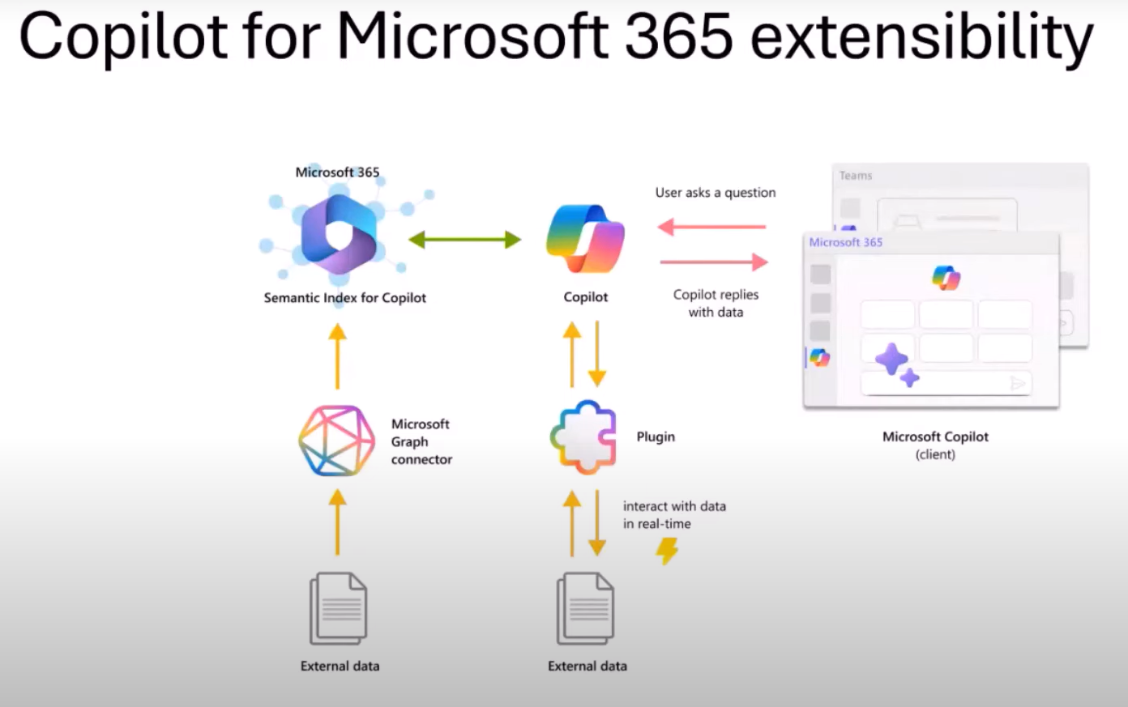

1. Using Microsoft Graph Connector: importing data from your external app into M365
2. Build a plugin: Copilot will retrieve the data on the fly based on your prompt, when your send a prompt Copilot will match the tools it has available and it will the one matchs with your prompt.

**What happens when you chat with M365 Copilot?**

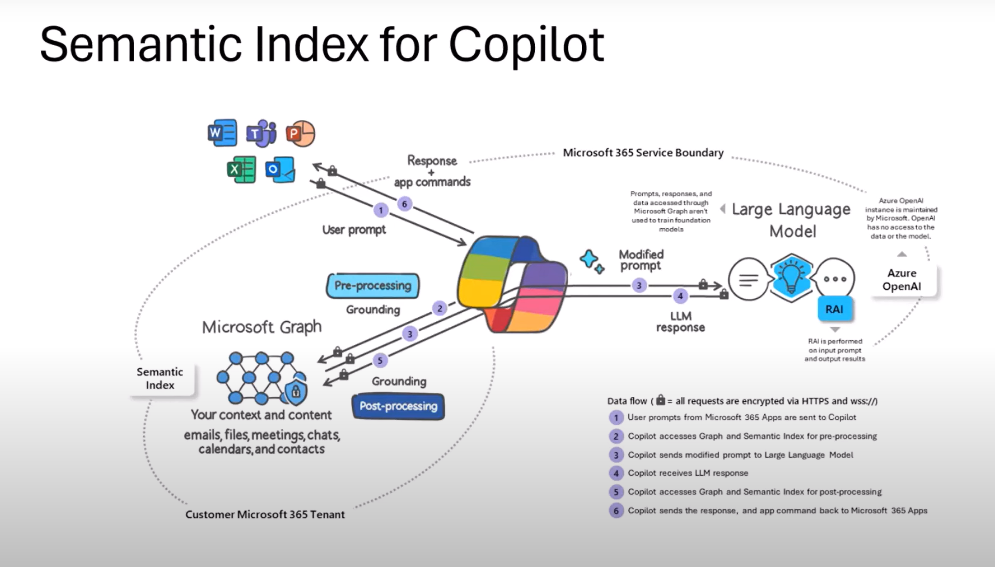

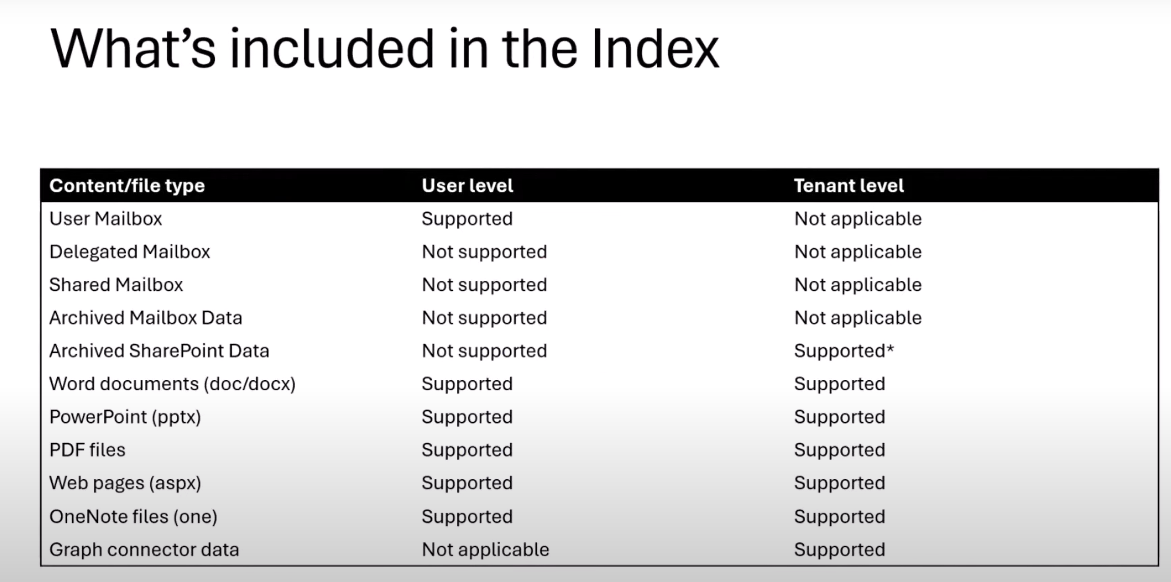

And some external data via Graph connectors, that we will see later.

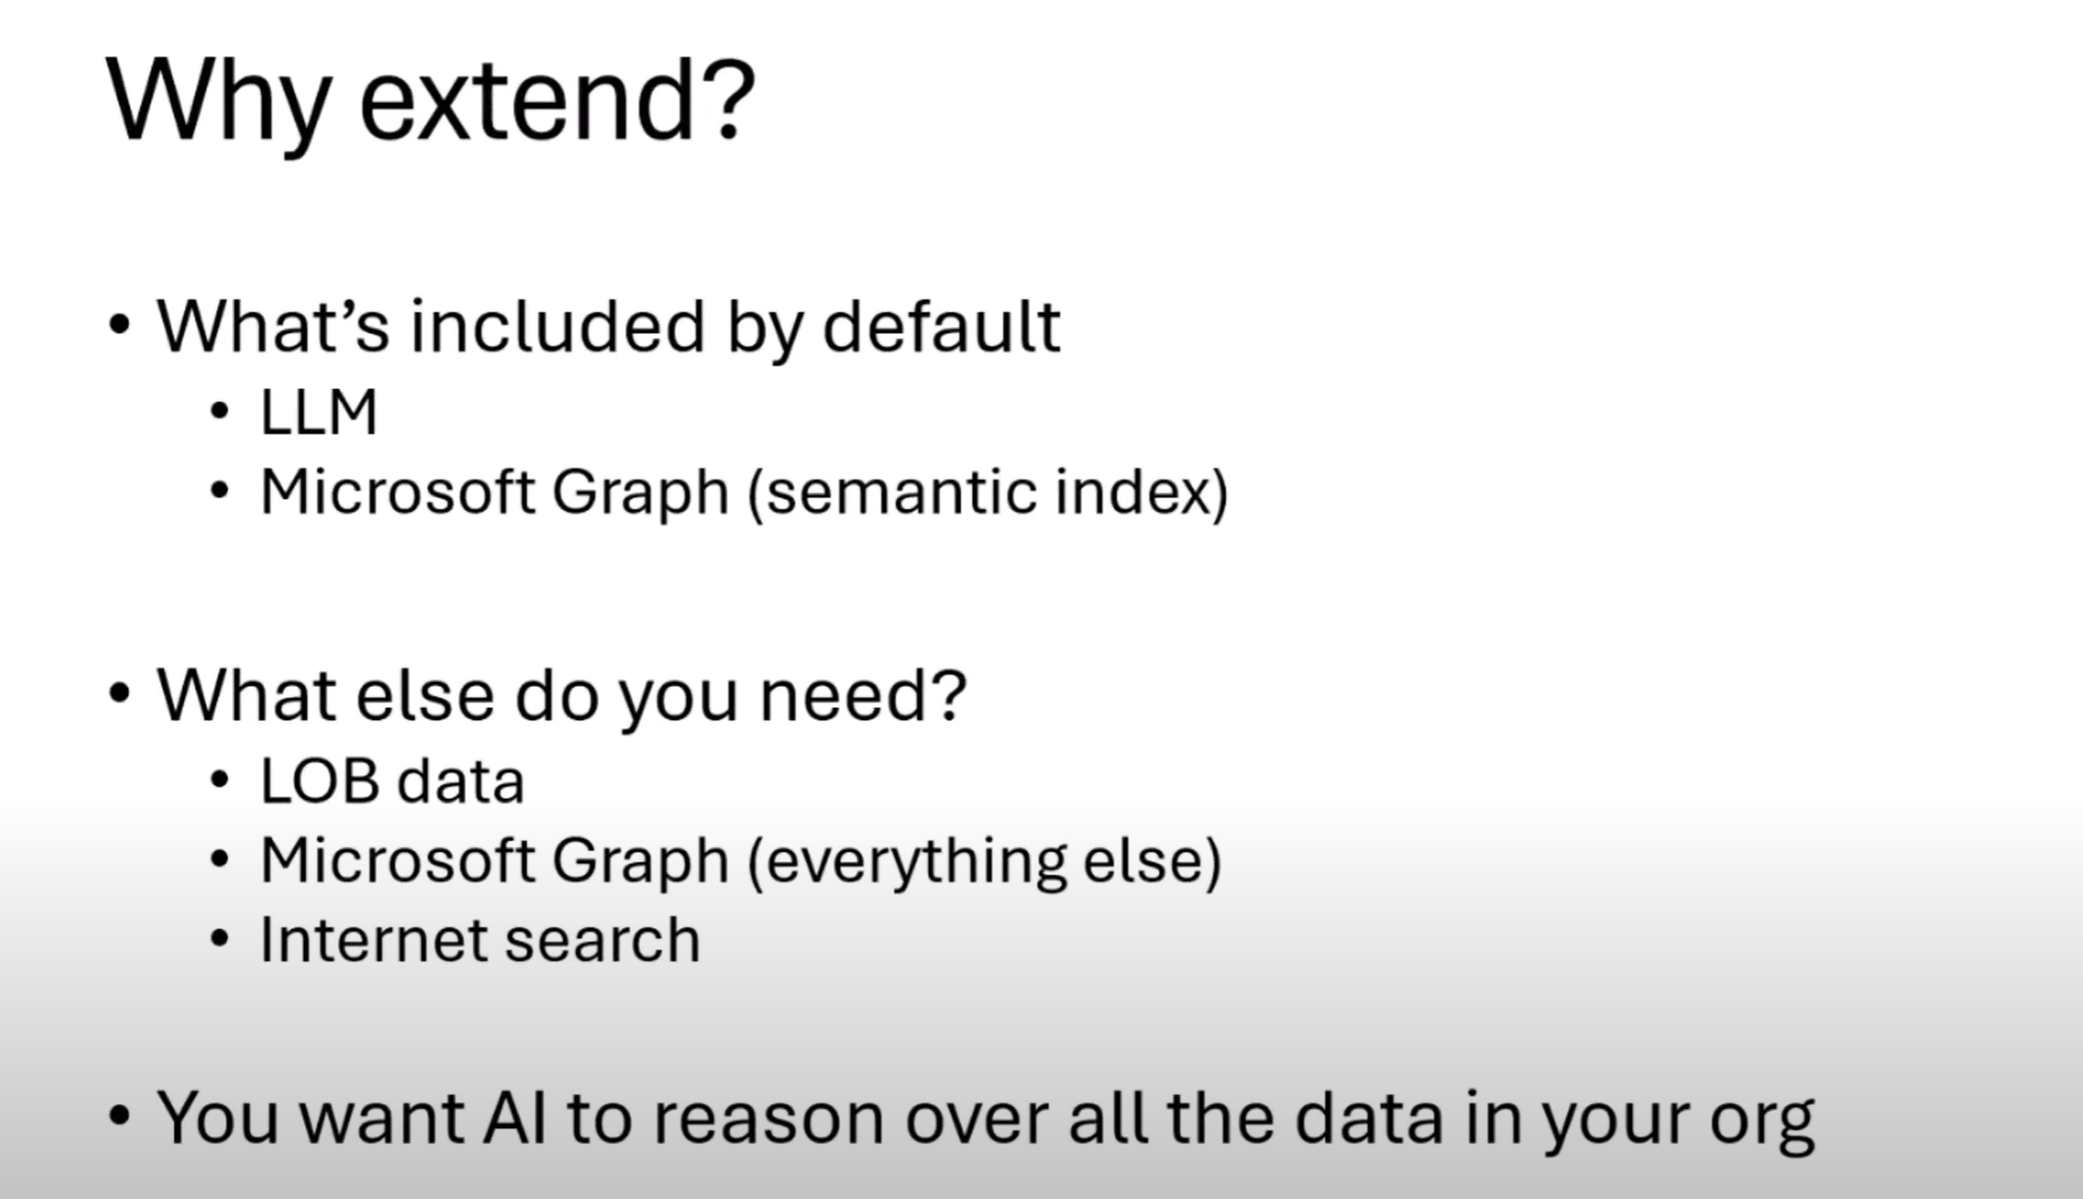

1. Extend Copilot for Microsoft 365 with plugins

<https://www.youtube.com/watch?v=ePLgSsje4Fw&t=885s>

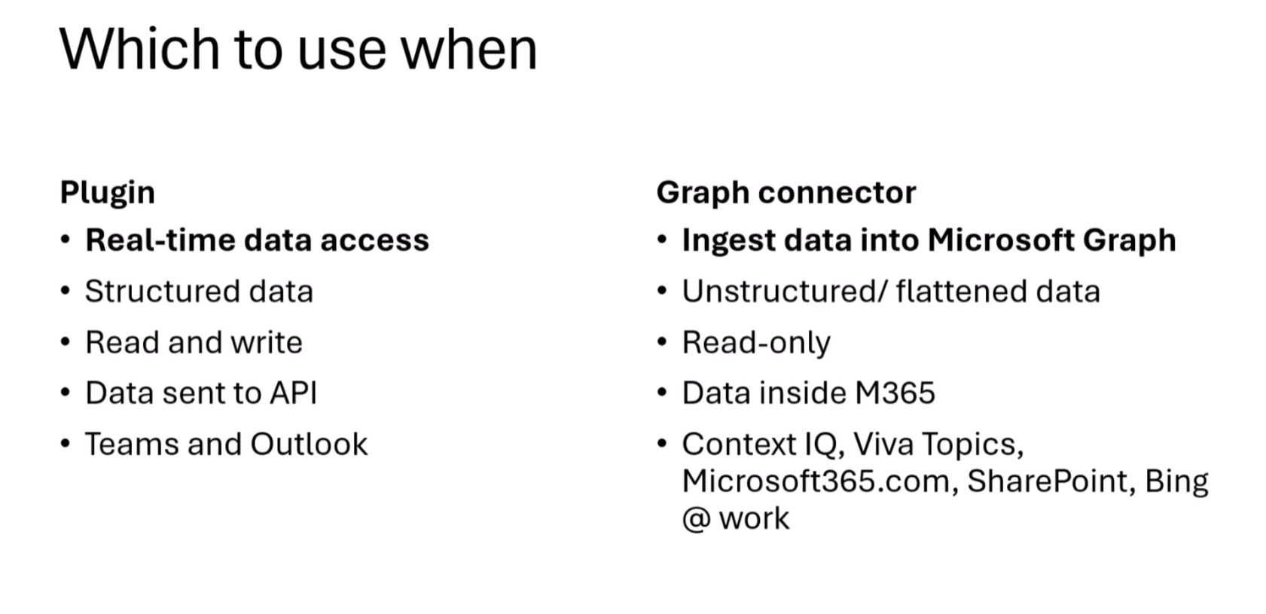

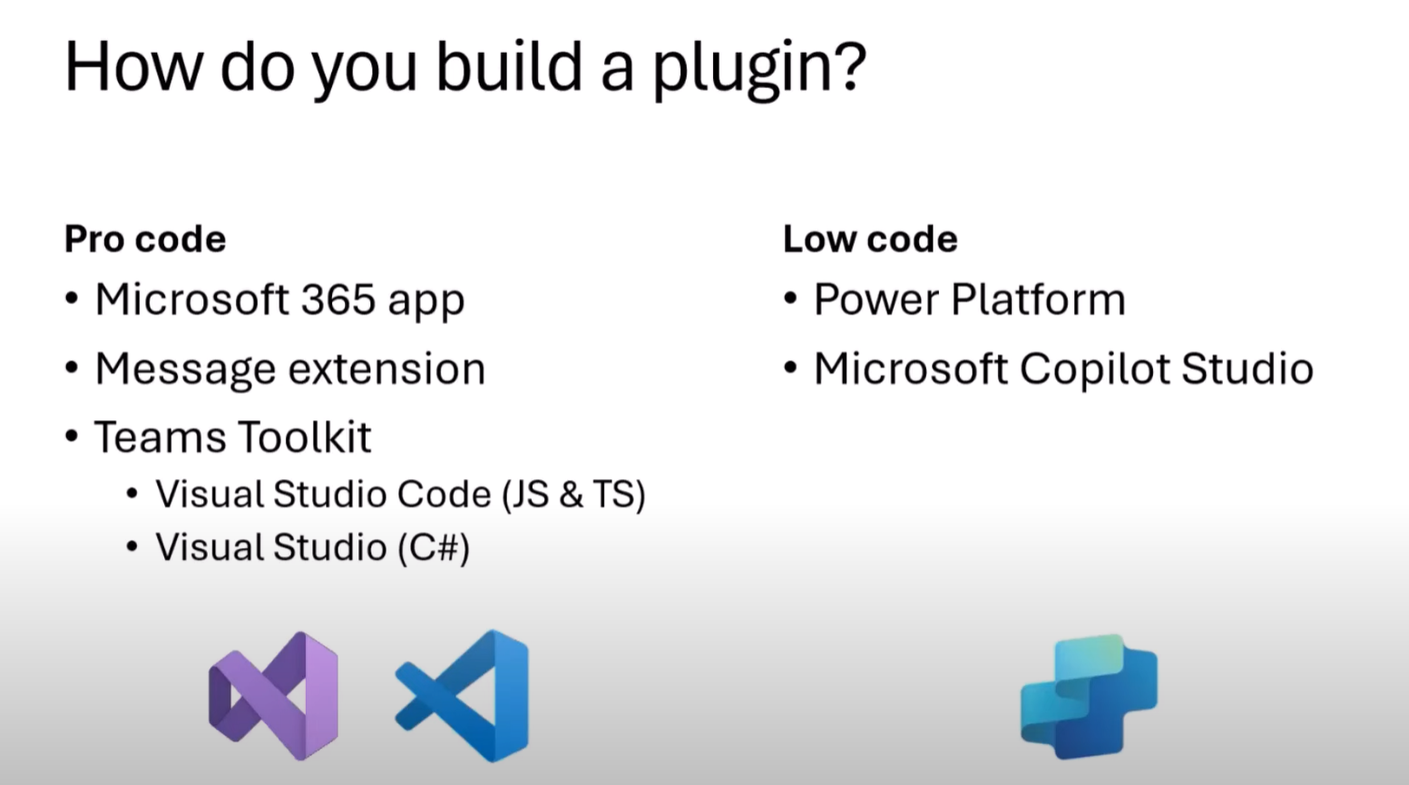



Message extension.

1. Extend Copilot for Microsoft 365 with Graph connectors

<https://www.youtube.com/watch?v=GSgRSqkntnI>

Microsoft Graph Connector has three main billers:

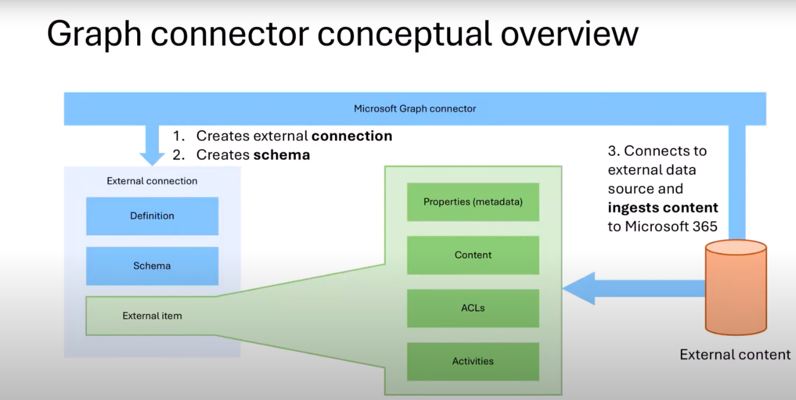

Connector can be simple:

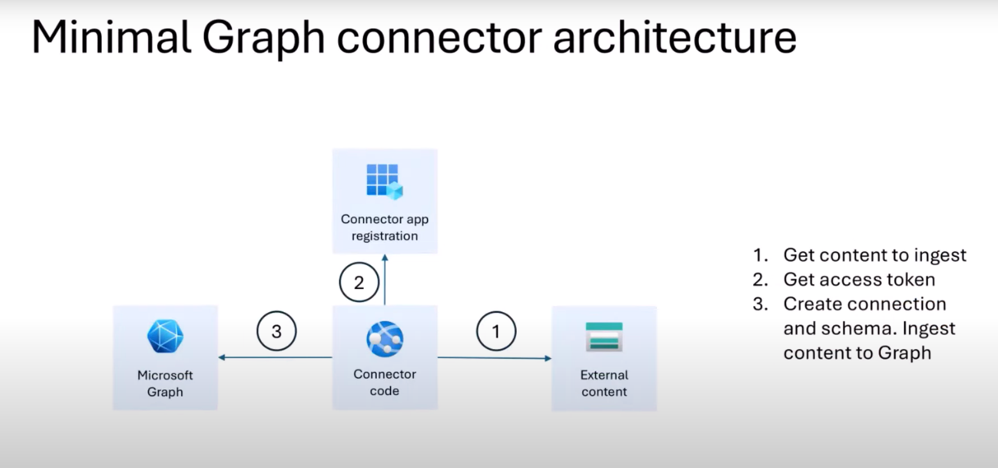

1. Fd